**Introduction and Background**

I decided to create a system that simulates a four-way traffic intersection. I sought to develop a circuit-based system that replicate aspects of everyday four-way traffic light intersections, such red, yellow, and green lights that transition appropriately to avoid collisions. In addition, I set out to include features such as vehicular detection, in order to notify the lights to switch to green for a particular direction of the four-way intersection, and emergency vehicle detection, in order to signal all lights to turn to red to simulate emergency vehicles having the right of way to pass through.

The design I selected for accomplishing my project goals involved using indicator LEDs to simulate the traffic lights, Hall effect sensors—which detect magnetic fields—to detect vehicles, an infrared photodiode to simulate the emergency vehicle signal, and an Arduino to program the necessary logic to control the traffic light transition process. The basic theory required for understanding the components I utilized in this project was mainly the concepts of photodiodes and of Kirchhoff’s loop laws for electrical current.

**Testing Methodology**

The components I utilized in my circuit design Were resistors, indicator LEDs, Hall effect sensors, an infrared photodiode, and an Arduino Uno. I begin by explaining how I verified the operation of each of these individual components before explaining how I verified the operation of the completed design.

I verified the functionality of the indicator LEDs by hooking them up in series with 1 kΩ resistors, passing a voltage of 5 Volts, and observing the brightness of the LEDs and whether or not they lit up. The schematic for these operational tests are depictured in Figure 1.

Next, I verified the operation of the Hall effect sensors by taking into consideration the orientation of the pins on the sensors, as shown in Figure 2, placing the pins in the circuit as depicted in Figure 3, for testing. and capturing the voltage readings from the Arduino pins linked to the sensors. Since the Hall effect sensors I Were using Were of the normally closed latch switch variety, when no magnetic field was present, the LED1 (see Fig. 3) would illuminate. By measuring the distance between a magnet and the sensor, I Were able to determine at what distance the Hall effect sensor would latch open and thus told us the maximum distance the sensor could be used in my final model (see Table 1).

I then verified the operation of the infrared photodiode by connecting the diode to the Arduino, as shown in Figure 4, and shining infrared light on it while recording the voltage recorded by the Arduino input pin connected to the diode. By using the serial terminal of the Arduino I Were able to observe voltage values from the photodiode and determine voltage as a function of distance between the photodiode and the IR testing bulb (see Table 2).

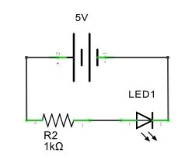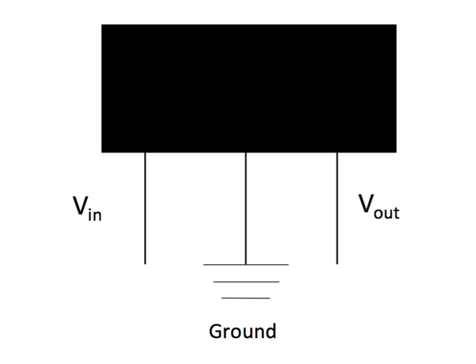

***Figure 1:*** *Testing schematic for the LED indicator light wired in series with resistor and 5V source. Used to test all LED bulb operation before final installation [3]*

***Figure 2****: Schematic labeling pins of a standard Hall effect sensor. Vin and Vout are near-identical voltages if the Hall effect sensor does not detect a magnetic field. However, if a field is detected, Vout will approach a near-zero value.[2]*

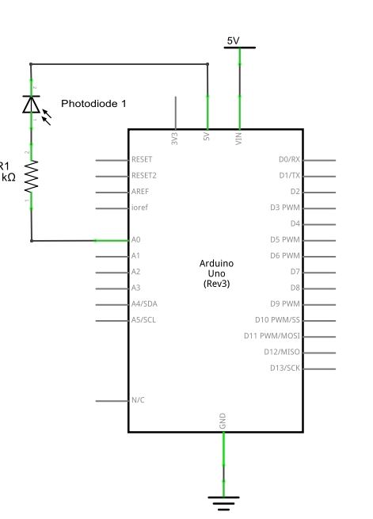

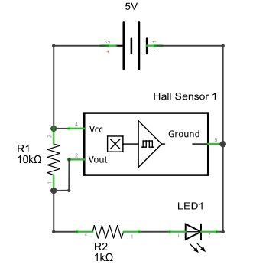

***Figure 4:*** *Testing circuit for Photodiode. Photodiode wired in series with resistor. Analog input of Arduino used to determine voltage through the photodiode under various lighting conditions. [3]*

***Figure 3:*** *Testing circuit for Hall effect Sensor. LED1 would not illuminate when the sensor detected a magnetic field. Used to test minimum effective distance for sensor operation.* *[3]*

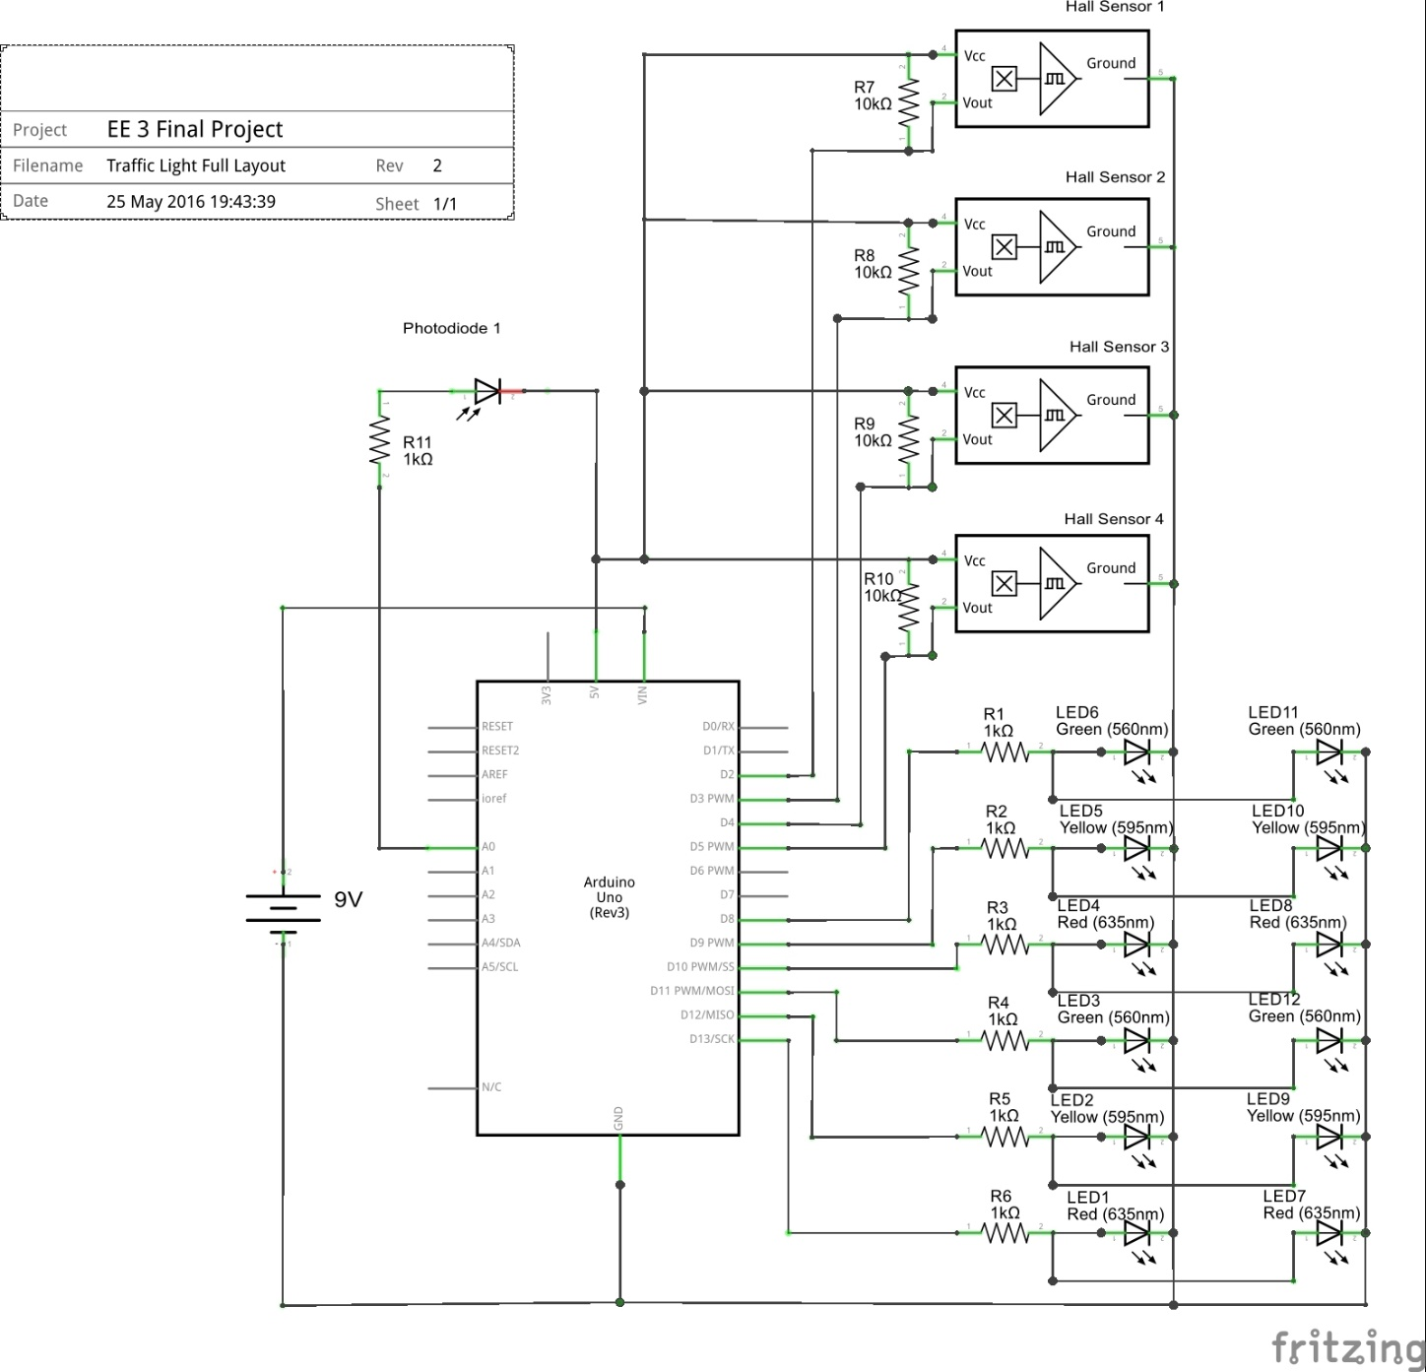

***Figure 5:*** *Full schematic for final implementation of the traffic light circuitry.*

Following that, I verified operation of the Arduino Uno unit by plugging it into a computer, writing a set of dummy C++ code, and compiling and building that code on the unit. The unit responded appropriately to the code and verified that it was operational.

Finally, I verified operation of the entire circuit design, as shown in Figure 5, by confirming that the system responded in accordance with the following rules:

1. By default, the system should have one direction set to green, while the other direction should be set to red. No change in signals should occur unless a vehicle is present in a direction stopped by a red signal.
2. When a vehicle is detected in a direction which the corresponding signal is red, simulated by a magnet being placed beside the Hall effect sensor, the green light in the direction perpendicular to the direction the vehicle is waiting should turn off and the yellow light should be activated. After 5 seconds, the light should switch from yellow to red.
3. Simultaneously with the changing of the lights from yellow to red in the previous step, the signal corresponding to the direction the car is waiting in should now switch to green, allowing this car to proceed through the intersection. There is now a 10 second cool down before the light can switch back to red.
4. Repeat #2 and #3 for all instances of vehicular detection. (In the event of continual vehicular flow or constant detection by the sensors, the lights will cycle in each direction for 10 seconds.
5. If the infrared photodiode is activated, the traffic signals indicating green should immediately complete step 2, disregarding any cool down that may be in effect. The perpendicular direction that is indicating red should remain red. There is also a 10 second cool down for this override and once completed, signal will return to normal operation.

With regards to designs I had to abandon, I originally tried to add the ‘emergency-bypass signal’ feature by utilizing a microphone and playing a sound of a certain frequency to notify the system when to activate the aforementioned rule #5. However, such a design was quite complicated to implement, as it turned that the process of transforming the sound waves into a function of frequency (Fourier transform) was too taxing on the single threaded operation of the Arduino. Hence, I deferred to utilizing the IR photodiode in my final design, as it did not require complex arithmetic operations.

**Results and Discussion**

|  |  |
| --- | --- |
| **Distance from Hall Effect sensor when sensor would latch on (detection)** | **Distance from Hall Effect sensor when sensor would latch off (no detection)** |
| 11 mm | 13mm |

***Table 1:*** *Using a 17mm diameter neodymium circular magnet I found that the sensor required a stronger magnetic flux to latch on, but latched off at a lower magnetic flux level. Meaning that once latched on the magnet could move around a little bit without worry of losing detection.*

|  |  |
| --- | --- |
| **IR indicator LED distance (cm)** | **Voltage (input of 5V normalized to 1023)** |
| Ambient Light (no LED) | 986 |
| 1 | 971 |
| 2 | 975 |
| 3 | 978 |
| 4 | 980 |
| 5 | 981 |
| 6 | 982 |
| 7 | 984 |
| 8 | 985 |
| 9 | 986 |

***Table 2:*** *Observable voltage drop as distance between the LED and the photodiode decreases. To insure that errant voltage values would not affect performance, in the final code I set a minimum of 4 voltage values less than ambient light as the threshold for detection. Meaning the IR LED must be placed at a minimum of 6cm from the photodiode. Values Were recorded using the “Serial Monitor” feature of the Arduino software.*

The results from these tests Were critical in understanding how my sensor’s operated as Ill as ascertaining their limitations. The data in Table 1 was crucial because 11 mm for the latch on distance meant that the magnet had to be relatively close to the Hall effect sensor. Since my sensor would be placed under my road surface, I had to ensure that the thickness of the road along with the gap from the road to the magnet under the car did not exceed 11mm. I also found through testing that the less distance between the magnet and the sensor resulted in a wider detection radius as the sensor appeared to have a hemispherical detection range with respect to its detection surface. These two factors influenced my decision to embed my sensors into the cardboard that was my road. This allowed for a mesh spot between detection radius and a guaranteed pickup of the magnet.

Although not originally accounted for, the extra 2cm of distance between the latch on and off points proved rather useful, as the car and magnet did not have to come to a stop directly over the sensor, but rather could roll around a bit and still be detected by the sensor.

With my analysis of the Hall effect sensor complete, I next turned my attention to the IR photodiode that would serve as an emergency vehicle override. I sought to understand at what distance from the photodiode the IR bulb could be placed so that I would not get false positives from changing room light conditions. To this end, through my testing of the photodiode I found that the voltage value reported by the Arduino would vary by at most 2 voltage values in each direction. For the data in Table 2, with no LED present my values would fluctuate anywhere from 984-988, although highly concentrated around 986. From this data I decided that it would be best to have a threshold of a loss of 4 voltage values before the Arduino accepts the data as an IR LED being present. Meaning that if the ambient light was 986, the voltage value would have to be at most 982 before any action would be taken. One issue I found was that power cycling the photodiode changed its reading of the ambient light. To alleviate this issue, I decided that when the Arduino is first powered up, an average reading of the voltage values of the photodiode would be taken and set as the ambient light level.

With this in mind I then determined the minimum distance between the IR bulb and the photodiode. From my data seen in Table 2, this distance turned out to be 6 cm from the diode. Although that distance is rather close to the sensor, I Were able to work around this by moving the photodiode away from the center of the intersection and mounting it on the side of a building (see Fig. 8). This change in location allowed us to mitigate the short detection distance and still maintain reasonable functionality of the bypass system.



***Figure 6:*** *Real-life rendering of partial circuitry of the traffic intersection control system. Schematic displays the Arduino, Hall effect sensors, resistors, and indicator LEDs. [3].*

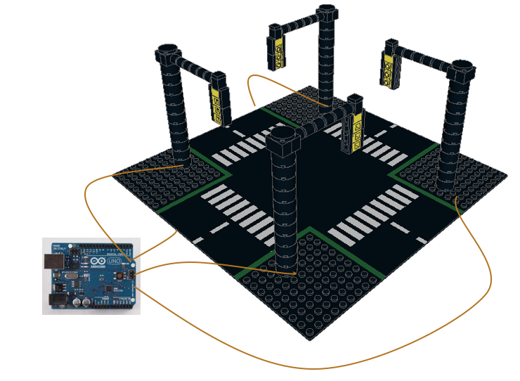

***Figure 7:*** *3-D rendering of completed, final design of traffic intersection control system. The rendering was generated through the LDView software. Image of the Arduino was used by the courtesy of [1].*

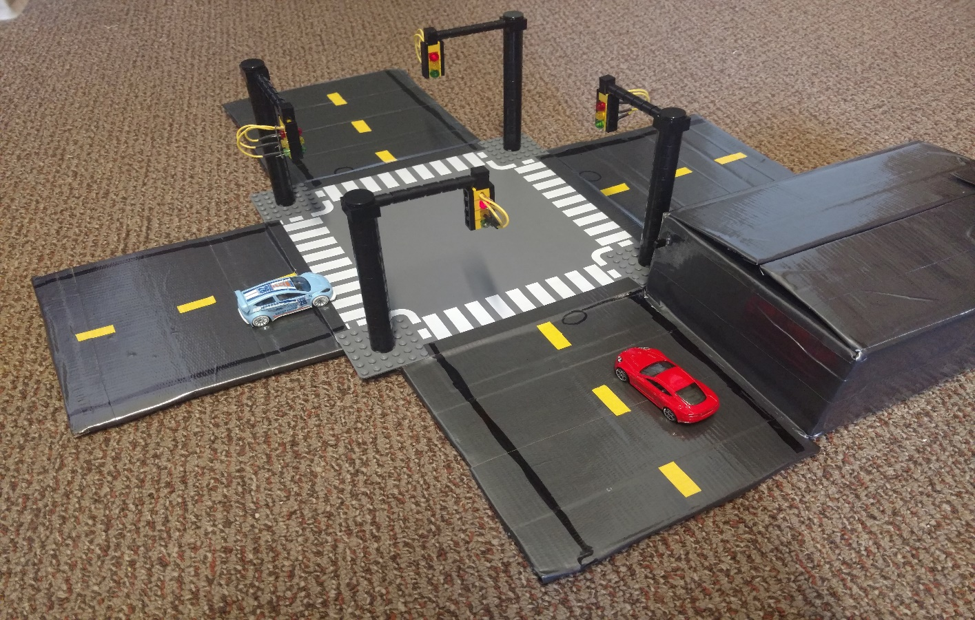

Hall Effect Sensor

IR Photodiode

Arduino

***Figure 8:*** *Image of finished design for traffic intersection control system. The circles on the road surface are where the Hall effect sensors are located under the road. The photodiode is mounted to the side of the box and the Arduino microcontroller and associated wiring is located inside the same box.*

**Conclusions and Future Work**

Our final design for the traffic intersection control system met my goals entirely, satisfying all the features and critical controls I had set out to include in my system. my final design is able to transition the traffic lights in a manner that would prevent collisions from occurring, I are able to detect cars with the Hall effect sensors and change the lights accordingly, and I are able to shift all the lights to red to simulate an emergency vehicle getting the right of way.

I learned about three things through the course of this project: what it means to place a load on a system, what the functional properties of photodiodes are, and the role of planning ahead in time-consuming projects.

In trying to configure the setup for the indicator LEDs and how to connect them to Arduino, which also acts as a power source for the circuit, I had to experiment with various resistors to see which resistance value, and thus load, allowed for optimal LED performance without blowing the bulbs.

When configuring the infrared photodiode and integrating it into the circuit, I learned first-hand that diodes have the property of one-directional current flow, or that diodes bias current to mainly travel in one direction. This was key in my final design as detecting this biased current with the Arduino allowed us to create the emergency-bypass signal feature for my traffic light system.

Finally, as I had close to five weeks working on this project, I learned the value of planning ahead and methodically crossing off action items on self-imposed check lists in order to avoid stress and loss of quality in my work. Through spreading out my work over the course of the project timeframe and accomplishing tasks I had set out for each of the weeks in the lab—along with meeting outside of lab to accomplish tasks that I may not have had a chance to finish in the lab sessions—I Were able to see the benefits of practical, organized planning in presenting functional, quality work.

**Code**

I utilized an Arduino to program the logic for my project, and have thus submitted a zip file with the Arduino code to CCLE.